Jolly Phonics in a Primary Intensive English Language Centre
How to Address Differentiation Using Technology and Peer Support
By Jan Polkinghorne Jolly Phonics Tutor/Trainer SPELD South Australia Inc.

Abstract: One of the strengths of the Jolly Phonics program is the power derived from the rapid introduction of one new letter sound a day. However, in some situations this becomes totally impractical. Perhaps it is a small rural school where the teacher has a number of different year levels in the same room and time is precious. Perhaps the adult supervisor does not speak English or the adult learner does not speak English. Many classes have one or two new students transfer in after the program has started. In Darlington Intensive Language Unit, the problem was that new non-English speaking migrants arrived in the class almost every day and each student needed a different letter sound introduced each day. The teachers knew Jolly Phonics worked, but the problem was how to make it work in their situation. See how Jolly Phonics Extra, a wider use of Jolly Phonics IWB software and some specialised apps helped bring about rapid improvement for most students.
Darlington Primary School, located in the southern suburbs of Adelaide, South Australia, is one of 18 Primary Intensive English Language Centres in South Australia. These centres provide intensive English language support for students from 5 to 12 years of age with specialist teachers of English as an additional language or dialect. Students with a language and cultural background other than English and who have limited or minimal English language are eligible to enrol if they meet specific criteria:
- Were born overseas in a non- English speaking country and living in Australia less than 12 months (or 18 months for Junior Primary aged students)
- Are a Refugee, Migrant or approved Temporary Resident
- Children who turned 4 on or before May 1 can enrol in a pre-school soon after arrival in SA
- Within 18 months of arrival for students in Reception and Year 1- (within 12 months of arrival for Years 2-7)
- Australian citizens or children of Australian citizens are eligible if English is not their first language and they meet the criteria above
Most students spend 4 terms in the IEL program (a possible 6 terms for refugees), before they move into a mainstream class and join in many of the activities of the mainstream classes during that time.
Year 7 students are expected to exit the program at Language Level 6 (mainstream Year 2). Using the Jolly Phonics and Jolly Grammar program, this would indicate that a Language Level 6 student has completed Jolly Phonics, Jolly Grammar 1 and 2. At Darlington there are 6 classes of IELP students, all with continuous enrolment. Students of all ages arrive with varying degrees of knowledge: - literacy students have never been to school and language students have received schooling in their country of origin. Many arrive knowing letter names but with no knowledge of sounds, blending, segmenting or writing. Class sizes vary throughout the year, but on average there are 13 students per class, often with 3 different year levels. Students come from all over the world - currently: Iran, Afghanistan, Saudi Arabia, China and Pakistan but this changes from week to week. Students can leave suddenly due to housing issues such as short term accommodation.

Staff at Darlington have all received Jolly Phonics training and were trying to implement the program but differing levels of ability and a steady stream of new students made introducing a new sound each day virtually impossible. So a teacher from the school contacted the Jolly Phonics trainers at SPELD, South Australia. with some questions:
- What do you think is the best way to group students to cater for differentiation? What would a lesson look like for the various groups?
- There were times when I was introducing a different letter to almost every student, every day, in order to follow the letter group sequence as recommended. This became extremely difficult to manage. How can I manage this better?
- The children who currently come to me for Jolly Phonics know a range of different sounds, so it would have only benefitted one or two students if I'd started again. Some of the children only needed to learn a few more sounds.
- You mentioned at training the importance of following the program specifically, to get the best results. Can you suggest how we can best use the Jolly Phonics/Jolly Grammar program, given our time constraints and the distinctiveness of an IELP?”
Year 7 IELP teacher, Darlington Primary.

After meeting with staff at Darlington, it was clear the teachers wanted to continue to use Jolly Phonics both because it is the program used in the main stream classes at Darlington and they know it gets results, but they needed to manage the differentiation for students in a more effective way. One of the keys to success with Jolly Phonics is the introduction of a new letter- sound every day for the first term. In schools with a continuous intake, like Darlington, it is difficult to accommodate this requirement. Teaching staff do not have the time to introduce a new sound to each student every day when this may mean a different sound for every student in the class. When you multiply this with the language barrier which slows things down even more and the time pressure of bringing students to the required language level before they exit the program, this was becoming a huge ask for both teachers and students.

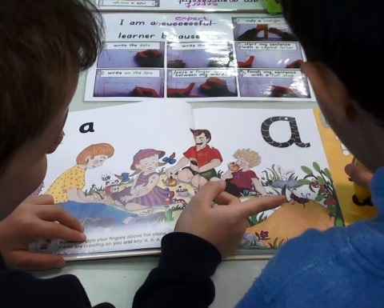
Following discussion with staff, we decided that using technology to do the introduction of the new letter sounds each day and much of the daily revision should help students to achieve the learning at their own level and at the same time develop independent learners. We settled on the use of Jolly Phonics Extra kits (1), a far wider use of the Jolly Phonics Interactive Whiteboard Software (2) and some Apps by Reading Doctor (3). All of the above were chosen because after being introduced to the technology, students would rapidly be self-sufficient, both in teaching themselves the new sound for the day, gaining enough daily practice to become automatic in their responses and to have immediate confirmation to know if they were correct. There was already a Buddy System operating in the school to help each new student settle in. We decided to extend the role of the Buddy to include the extra step of showing a new student how to use the Jolly Phonics Extra Pen, software and the IPad Apps. Students were given a graphic, numbered flow chart to set up a system for the lessons. One teacher commented “The buddy system was only needed for a short time but it took away the fear of using the device for the first time for students who have never been to school and may never have used any form of technology. It also promoted confidence, friendship and support in a classroom of diversity.” Jolly Phonics Extra Talking Pen was used to introduce the new sound for the day, revise known sounds, blend words on flashcards and practise reading with readers.
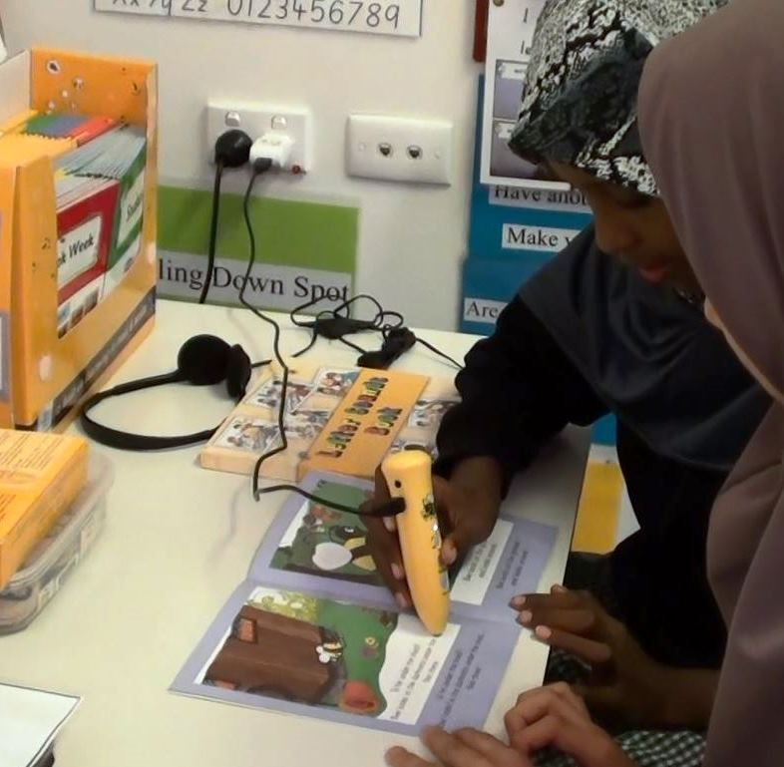
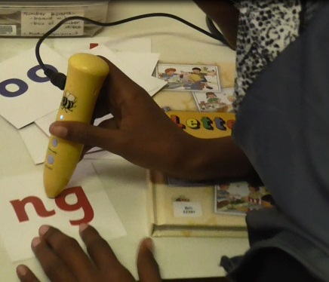
A study was set up to evaluate the acquisition of letter-sound knowledge of new arrivals. 29 students from 5 different countries aged between 5 years 1 month and 12 years 7months took part in the study. Students were allotted 30 minutes a day divided between the Jolly Phonics Extra Talking Pen, use of Jolly Phonics IWB Software on a laptop and the Learning Doctor Apps on the IPad. Waddington Tests were used to assess base levels before they began and again after 7 months. The Jolly Phonics Sound Checklist was also used to assess the rate at which they acquired letter- sound knowledge. In the 7 months of the trial 19/29 could recognise all 42 letter sounds and 16/29 could write all letter sounds with many achieving this in a much shorter time span than this. Waddington’s Spelling test was used because it is suitable for students of any age, the first 12 words cover all of the sounds of the letters of the alphabet and teachers have access to separate phonic/decodable words from sight words.
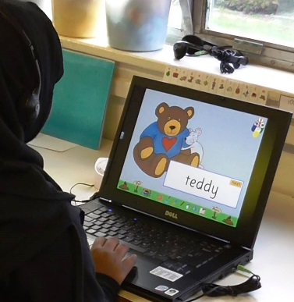
In the 7 months of the trial, 17 students managed a spelling age increase of over 2 years on the Waddington’s test. A fundamental flaw in the set-up of the study was not realised until too late and that was that we were told we were not to add extra students into the data collection after the commencement of the study. When part of the aim of the project was to see how teachers and students coped because of the continuous enrolment, this meant that we were left with no way to really measure this. Some of the data collected is shown below.

Probably more important than the data in this case, are the teachers’ comments about what had been achieved by using technology in this way. Most teachers felt that students had progressed at a faster rate than they had prior to the use of the technology. Many commented that all students, even those with no English had been able to commence meaningful learning from day 1 of the program. “The multisensory approach covers different learning styles, engages students in their learning and empowers students by regulating their learning without much help from the teacher.” “Self-regulation- students feel like they don’t have to ask the teacher all the time. One of my students commented that she liked the fact that no-one else knew how many times she listened for the difference between ‘a’ and ‘i-e’ because she had the headphones on.” The approach encourages safe risk taking by allowing students to work independently at their own pace. It helped develop students’ self-esteem and was a definite help in developing vocabulary for IELP students. Many teachers commented on problems with the pen which was really tested to the limit with almost continuous use throughout the day. The pen worked better when connected to the mains via an adaptor than when connected to the USB port on a computer. This also freed the computer for other use by another student. For such continuous use, battery consumption became very expensive and connections eventually needed to be “jiggled” to be effective. A longer USB cable would have been an advantage. Several teachers commented that the phonetic spelling on flashcards and readers was more of a confusion than an asset to students learning English as a second language. Some teachers commented that the stories and songs were narrated too quickly by the Talking Pen for students learning to speak English. A few of the younger students found it difficult to use the pen without accidently clicking the buttons. From the students’ comments, some liked the Talking Pen because it helped them learn the sounds better and they could work on their own. Others liked the fact that they could check if they were correct when reading a story. Several commented that they could all do different things and that it helped them learn faster. Many found it frustrating that the batteries would run out in the middle of what they were doing. Aside from the few technical issues, most students felt the pen helped them learn faster and it certainly provided the teacher with ‘an extra pair of hands.’

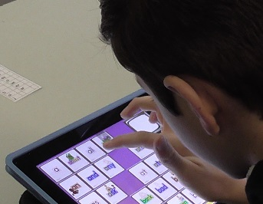
The Reading Doctor Apps were a hit with students of all ages and teachers. “They were lots of fun and helped me learn.” “They helped me learn fast.” “The Apps said the words and helped you to sound the words out.” “It looked like you were playing a game.” Teachers commented that the apps needed little instruction from the buddy as they were pretty intuitive and already differentiated but that the Buddy System built confidence for those new to school and new to devices. It was also empowering for the Buddy to take on the responsibility to teach someone else and helped to develop friendships. The main drawback seen by most teachers was that they only had 1 IPad per class which severely limited the time students could spend. “Great tools in a differentiated learning environment.” Different apps were better for students of different skill levels. Jolly Phonics Extra was extremely good for introducing sounds, expanding students’ English vocabulary and helping students when reading books but the Reading Doctor Apps were very good for continual repetition to develop automaticity of letter sound knowledge and sight word knowledge. They also helped develop skills with blending and segmenting.
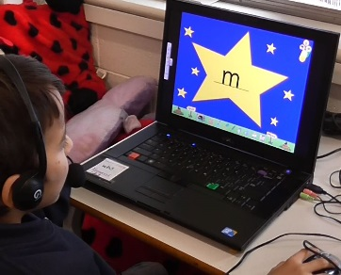
Although limited because they only had 1 laptop per classroom, the teachers felt they had been able to get wider use out of the Jolly Phonics IWB software by allowing students to use it in pairs or small groups for revision. This could have been expanded even further if more laptops were available. The major advantage of the Jolly Phonics Extra program and talking pen over the IWB software, was that students could get immediate confirmation of an answer e.g. letter sound or word flash card, and of whether they had decoded correctly when reading a book.

Most teachers felt that the introduction of the technologies had helped them to further differentiate in an already differentiated program. It had certainly helped to get over the problem of a continual enrolment program particularly when using a program like Jolly Phonics which relies on introducing a new letter sound every day to students. Although teachers felt they had been significantly curtailed in their use of the technologies by difficulties with the school computer system, insufficient laptops and IPads for each classroom to gain maximum advantage of the software and apps provided, they could certainly see the potential of such technologies. Many commented on the way in which the use of the technology and the Buddy System had helped develop friendships more quickly and helped new students fit in more quickly.

Other applications
Differentiating content for students of different ages and abilities is also a problem for smaller country schools where a teacher may be teaching 4 year levels in one room and has to micro manage time for each lesson. Many teachers may have one or two students whose first language is not English in their class.

Cost comparisons

Often the cost of a site licence of Jolly Phonics IWB software is prohibitive for small country schools that may only have 1 or 2 students in Junior Primary classes. In these schools, the Jolly Phonics Extra Talking Pen system may achieve similar ends in a more affordable way. Similar approaches to those tried at Darlington may prove useful in a range of situations.

- For a more detailed description of the Jolly Phonics Extra Kit see: www//jollylearning.co.uk/jolly-shop/jolly-phonics-extra/
- For further details on Jolly Phonics IWB software see: www://jollylearning.co.uk/jolly-shop/jolly-phonics-for-the-whiteboard/
- Reading Doctor Apps provided by Bartek Rajkowski:- Letter Sounds 1 & 2, Word Builder, Blending Sounds, Sight Words. Although these apps are not Jolly Phonics teaching aids they are pre-set with Jolly Phonics letter sound groups so are extremely easy to integrate with the Jolly Phonics Program. http://www.readingdoctor.com.au/ or from The App Store.

Summary Results Each Student
Student Identification | DOB | Waddington Spelling test 2/2015 | Waddington Spelling test 9/2015 | 1/2015  Say Jolly P  Sounds/42 | 1/2015 JP  Write Jolly P Sounds/42 | 3/2015  Say Jolly P  Sounds /42 | 3/2015  Write JP  Sounds /42 | 9/2015  Say Jolly P  Sounds/42 | 9/2015  Write JP Sounds/42
1 | 25/4/04 | 6-7 | 9-5 | 0 | 0 | 40 | 39 | 42 | 42
2 | 14/10/03 | 8-2 | 10-10 | 28 | 26 | 41 | 41 | 42 | 42
3 | 14/11/04 | 7-0 | 8-1 | 14 | 0 | 42 | 42 | 42 | 42
4 | 26/12/04 | 8-8 | 10-4 | 42 | 42 | 42 | 42 | 42 | 42
5 | 28/7/02 | Couldn’t write | 10-2 | 0 | 0 | 38 | 19 | 42 | 42
6 | 2/1/03 | Couldn’t write | 9-2 | 40 | 29 | 39 | 38 | 42 | 42
7 | 26/10/07 | 5-9 | 7-10 | 37 | 34 | 40 | 42 | 40 | 42
8 | 5/7/07 | 5-9 | 8-3 | 0 | 0 | 42 | 39 | 42 | 42
9 | 30/3/06 | 5-9 | 8-3 | 21 | 28 | 38 | 40 | 42 | 42
10 | 5/10/06 | 5-9 | 8-4 | 12 | 13 | 39 | 42 | 42 | 42
11 | 4/3/07 | 6-11 | 8-1 | 37 | 22 | 42 | 32 | 42 | 42
12 | 8/4/07 | 5-9 | 8-8 | 0 | 0 | 33 | 17 | 33 | 35
13 | 21/3/09 | 5-9 | 7-5 | 0 | 1 | 8 | 8 | 42 | 37
14 | 25/08/09 | 6-5 | 8-7 | 33 | 16 | 41 | 37 | 42 | 42
15 | 26/5/09 | 6-3 | 8-8 | 16 | 10 | 35 | 31 | 42 | 42
16 | 25/08/09 | 5-9 | 8-0 | 4 | 4 | 15 | 5 | 42 | 40
17 | 26/1/10 | 5-9 | - | - | 0 | 0 | 0 | 37 | 34
18 | 19/10/09 | 5-9 | 7-7 | 6 | 0 | 18 | 6 | 39 | 33
19 | 11/7/09 | 5-9 | 6-0 | 0 | 0 | 3 | 2 | 27 | 19
20 | 23/6/08 | 5-9 | 8-9 | 19 | 14 | 22 | 18 | 42 | 42
21 | 11/1/09 | 5-9 | 7-8 | 0 | 0 | 21 | 4 | 41 | 31
22 | 4/8/08 | 5-9 | 7-2 | 0 | 0 | 13 | 4 | 41 | 41
23 | 19/9/08 | 5-9 | 8-2 | 7 | 3 | 20 | 6 | 42 | 42
24 | 15/6/09 | 5.9 | 6.7 | 0 | 0 | 18 | 0 | 42 | 32
25 | 17/11/08 | 5.9 | 7.10 | 3 | 27 | 34 | 27 | 41 | 36
26 | 17/11/08 | 5.9 | 7.9 | 26 | 18 | 28 | 30 | 42 | 41
27 | 10/9/07 | 5.9 | 7.4 | 26 | 0 | 42 | 30 | 40 | 37
28 | 20/2/08 | 5.9 | 8.7 | - | - | 5 | 5 | 42 | 42
29 | 5/1/07 | 5.9 | 8.1 | 14 | 0 | 19 | 25 | 34 | 38

