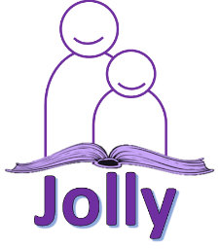
Training Course: Introduction to Jolly Phonics
Discover a fun way to teach phonics, spelling, grammar and punctuation in your school!
This one-day training event provides an introduction to Jolly Phonics, covering the 5 key skills of teaching children to read and write in English: learning the letter sounds, letter formation, blending, segmenting and tricky words.
• Teaching the 42 letter sounds and letter formation
• Blending for reading
• Segmenting for writing
• Tricky words
• Delivering Jolly Phonics lessons
• Introducing the first alternative letter sounds
• Practical ideas you can take back to the classroom
What is Jolly Phonics?
Jolly Phonics is a fun and multi-sensory literacy programme for teaching children to read and write in English.
Based on synthetic phonics, the UK’s mainstream teaching method, Jolly Phonics enables children to become fluent and confident communicators through child-centred teaching approaches.

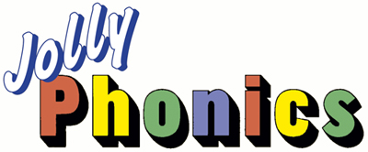

Who Should Attend?
The course is ideal for all English language teachers, head teachers and literacy assistants.
Price 6480₽
Fee includes all handouts, lunch, refreshments and certificate of attendance.
Date and venue
Moscow 26 November 10:00- 17:00
Panorama Maxima Hotel
4 Maskerkova street
Autozavodskaya Tube Station

St Petersburg 27 November 10:00-17:00
Educational Center “Akademija Rosta”
78 Nevsky Prospect
Majakovskaya Tube Station

Contact Details
Tel.: +7 921 903 1771
E-mail: info@jollyenglish.org
Web site: jollyenglish.org
If you would like us to come your city, please email headteacher@jollyenglish.org

